Board Paper XX

Somewhere or Other NHS Board

3 February 2014

Healthcare Associated Infection Position Report

Author:  Infection Control Manager  Business Manager | Sponsoring Director:  Medical Director
Date: 16 December 2013

Recommendation

NHS Board members are asked to review the latest Healthcare Associated Infection (HAI) data; in particular the projected year end position against the two HAI related HEAT targets.

Summary

From 1 April 2013, the Infection Prevention and Control Team (IPCT) began work towards achieving the HAI HEAT targets which are:

- To achieve a rate of no more than 0.32 cases per 1,000 occupied bed days for CDI in the 15 and over age group by the year ending 31 March 2015; and
- To achieve a rate of no more than 0.24 cases per 1,000 acute occupied bed days for SABs by the year ending 31 March 2015.

Glossary of Terms
AMT Antimicrobial Management Team
CDI Clostridium difficile Infection
CDT Clostridium difficile Toxin
CVC Central vascular cannula
GG&C Greater Glasgow & Clyde
HAI Healthcare Associated Infection
HAIRT Healthcare Associated Infection Reporting Template
HEAT Health, Efficiency, Access, Treatment
HEI Healthcare Environmental Inspectorate
HPS Health Protection Scotland
HPT Health Protection Team
IPCT Infection Prevention & Control Team
PVC Peripheral vascular cannula
SAB Staphylococcus aureus bacteraemia
SGHD Scottish Government Health Directorate

- Staphylococcus aureus Bacteraemias (SABs)
- Our last verified SAB rate was 0.25 for the year ending June 2013. Our projected rate for the year ending September 2013 is 0.25 (see chart 1).
- In order to allow real time tracking against the SAB HEAT target, a new numerical target of no more than 6.5 cases per month has been established. This is a slight underestimation to account for any significant decrease in the acute occupied bed days over the 2 years of the target.
- There are 57 SABs attributable to the HEAT target (5 SABs above the monthly trajectory at this point in the activity year, 1 April – 30 November 2013) as shown in chart 2.

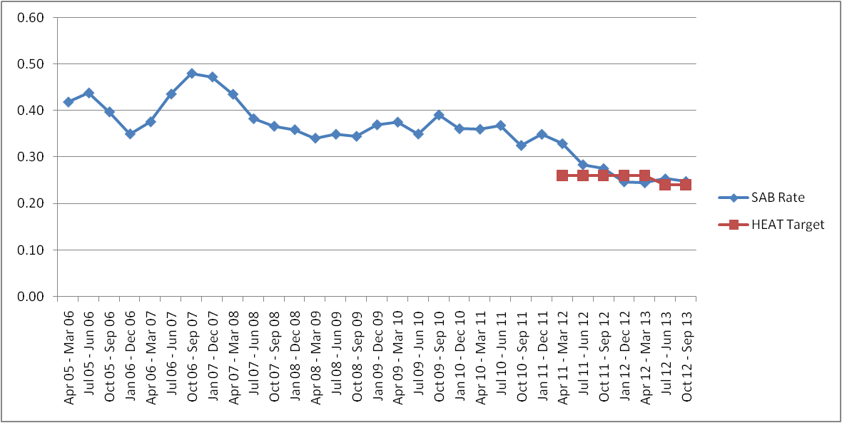
Chart 1 – Rolling Annual SAB Rate Set Against March 2015
HEAT Target

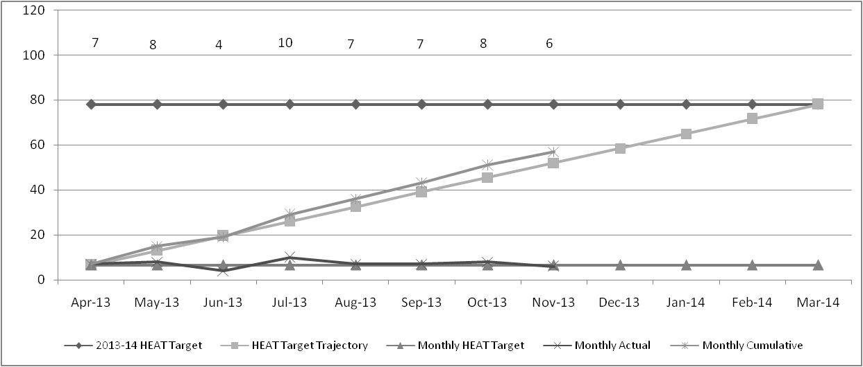
TOTAL 57 SAB CASES
(5 SABS ABOVE LOCAL TRAJECTORY)
Chart 2 – SAB HEAT Target (Year 1, 2013-14) monthly position

- The programme of work continues aimed at improving staff competencies in managing CVCs and this programme is being led by the Nurse Consultant in Cancer. The programme will ensure a standardised approach to infection prevention in the management of central lines.
- Outwith vascular access devices, there are challenges in determining areas of intervention based on current epidemiological knowledge.
- There is a high percent of SABs categorised with an ‘unknown’ or ‘other’ cause which equates to almost 25% of SABs. This is either because the cause cannot be determined or because there may be more than one possible option and it is not possible to determine what the most likely cause is. The highest primary cause of our cases to date is related to skin & soft tissue at around 32%.
- There has also been an overall decrease in each source of acquisition category since 2010-11. The proportion assessed as community acquired and community onset / healthcare associated account for the majority of SAB cases.
- In a bid to raise epidemiological knowledge of SABs, the IPCT continues working with other NHS Boards to collate local surveillance data to (a) develop a better understanding of SAB epidemiology and (b) allow benchmarking so that best practice can be shared.
- The results indicate that nationally the focus for intervention should remain on vascular access devices (central and peripheral vascular). These have accounted for 5% of our SABs since 1 April 2013.
- The SAB HEAT target spans over 2 years which enables the organisation to ensure that the reductions made to date are sustainable whilst at the same time working collaboratively at a local and national level to identify and implement further interventions to ensure that we meet the new target by 31 March 2015.

2. Clostridium difficile Infections (CDIs)
- Our last verified CDI rate was 0.46 for the year ending June 2013. Our projected rate for the year ending September 2013 is 0.45 (see chart 3).

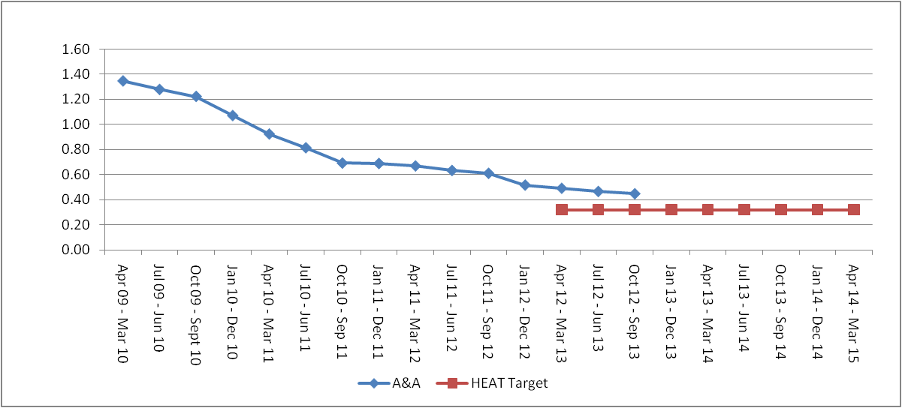
Chart 3 – Rolling Annual CDI Rate (15+ Age Group)
Set Against March 2015 HEAT target

- In order to allow real time monitoring and management of the CDI HEAT target, a numerical target of no more than 10 cases per month has been established.
- There are 113 cases of CDI between 1 April – 30 November 2013 (31 cases over the locally set monthly trajectory) assuming the target was required to be met by March 2014 (see chart 4).
- There is evidence that our monthly rate is declining from the unexplained peak in the summer, however it is not yet possible to determine whether this is being sustained.

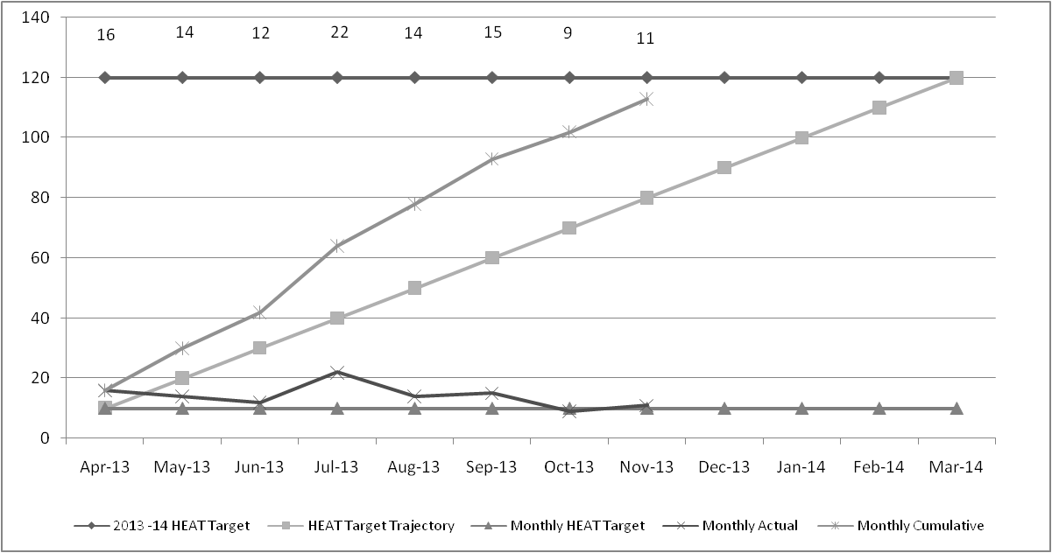
TOTAL 113 CDI CASES
(31 CDIs ABOVE LOCAL TRAJECTORY)
Chart 4 - CDI HEAT Target 2013-14 monthly position

- The Infection Control Manager (ICM) and Principal Antimicrobial Pharmacist are currently leading a review of our CDI reduction strategy to determine what interventions are required to allow the target to be attained. The actions to date include:
- The completion of visits to other NHS Boards to determine what additional approaches, if any, are being undertaken in areas with lower rates.
- The conclusions drawn from the visits are that:
- Our infection control and environmental cleaning procedures are consistent with other NHS Boards.
- Our laboratory protocol for testing for Clostridium difficile toxin (CDT) was different from other NHS Boards. Locally, we test all stool samples for CDT; the national guidelines stipulate only diarrhoeal stools. The testing of all samples will result in the identification cases of asymptomatic colonisation which are included in our official figures.
- Two of the 5 NHS Boards are applying a surveillance definition to determine what cases are included in the official HEAT target returns.
- Controlling antimicrobial prescribing is considered to be the most important driver in reducing CDI in these NHS Boards.
- In one NHS Board, individual directorate targets have been established ensuring local ownership. In addition all investigations into deaths and severe cases are undertaken by the relevant clinical team with the IPCT providing expert advice if required.
- Following on from these visits, a number of actions have been implemented or require further consideration which includes:
  - The Microbiology Laboratory has reviewed the criteria for CDT testing and since 28 October 2013, the laboratory now only tests diarrhoeal samples. An all staff e-mail was issued 22 October 2013 to advise clinical teams of the changes. It is not possible to determine the impact of this change on the overall number of positives as yet but it will aid reductions in our CDI rate.
  - The Infection Control Manager is currently developing a surveillance definition to be utilised by the IPCT in determining what cases should be included in our HEAT target returns to Health Protection Scotland (HPS). Once this is agreed locally, it will be shared with HPS to ensure both transparency and compliance with the national surveillance protocol.
  - Local ownership was identified by NHSGG&C as one of the key drivers in reducing CDI rates. This has manifested the development of local targets and local responsibility for CDI investigations. Adoption of such an approach locally has been proposed previously but did not meet with the required support. Based on the NHSGG&C experience there is a strong argument for revisiting this to determine if it is feasible.
- The visits also highlighted that our local data on antimicrobial prescribing is of a much higher quality than many other NHS Boards.
- The NHS Board is also participating in a national enhanced surveillance programme, which is being co-ordinated by HPS, of community related CDI cases, i.e. those that are identified in primary care or within 48 hours of admission to hospital.
- Preliminary analysis shows that 89% of these cases have had at least 1 antibiotic in the 12 weeks prior to onset of symptoms and only 36% had a 4C antibiotic.
- This reaffirms the view of the AMT that the focus of our antimicrobial strategy needs to shift from emphasising reductions in 4C prescribing to drive down our CDI rates to reducing our overall level of prescribing of all antibiotics.
- Our challenge is to reduce the overall level of prescribing of antimicrobials, especially within the hospital setting. Plans are currently being developed for a major local campaign in 2014 on the prudent prescribing of all antibiotics. The aim of the campaign will be to support clinicians to reduce the overall level of antimicrobial prescribing in the organisation.

Monitoring Form

Policy/Strategy Implications | Not required. This update report has no policy/strategy implications.
Workforce Implications | Not required. This update report has no workforce resource implications.
Financial Implications | The continual management and monitoring of HAIs in NHS Somewhere or Other in driving down infection rates as far as possible will ensure that costs per patient stay (ie treatments, length of stay, terminal ward cleaning etc) will not be impacted upon, ensuring that costs are minimised across the organisation.
Consultation (including Professional Committees) | The HAI update is also provided to the Healthcare Governance Committee bi-monthly and to the Prevention & Control of Infection Committee at every meeting (4 times per year).
Risk Assessment | Assessments are carried out on the HAI alert organisms by the Infection Control Nurse responsible for that particular clinical area to ensure that all necessary standard infection control precautions are initiated as appropriate in managing the patients care.
Best Value

- Vision and leadership
- Effective partnerships | Yes
- Governance and accountability | Yes
- Use of resources
- Performance management | Yes
Compliance with Corporate  Objectives | Patient Safety
Single Outcome Agreement (SOA) | Not required. This is an update report to NHS Board members.
Impact Assessment
Equality Impact Assessment (EQIA) not required as this is an update report to NHS Board members.

Appendix 1

Healthcare Associated Infection Reporting Template (HAIRT)
Section 1 – Board Wide Issues
This section of the HAIRT covers Board wide infection prevention and control activity and actions. For reports on individual hospitals, please refer to the ‘Healthcare Associated Infection Report Cards’ in Section 2.

A report card summarising Board wide statistics can be found at the end of section 1

Key Healthcare Associated Infection Headlines
- As at 30th November 2013 there have been 57 SABs contributing to the HEAT target. This is 5 SAB cases over trajectory.
- As at 30th November 2013 there have been 113 cases of CDI contributing to the HEAT target. This is 31 above trajectory.

Staphylococcus aureus (including MRSA)
Staphylococcus aureus is an organism which is responsible for a large number of healthcare associated infections, although it can also cause infections in people who have not had any recent contact with the healthcare system. The most common form of this is Meticillin Sensitive Staphylococcus Aureus (MSSA), but the more well known is MRSA (Meticillin Resistant Staphylococcus Aureus), which is a specific type of the organism which is resistant to certain antibiotics and is therefore more difficult to treat. More information on these organisms can be found at:
Staphylococcus aureus : http://www.nhs24.com/content/default.asp?page=s5_4&articleID=346
MRSA: http://www.nhs24.com/content/default.asp?page=s5_4&articleID=252
NHS Boards carry out surveillance of Staphylococcus aureus blood stream infections, known as bacteraemias. These are a serious form of infection and there is a national target to reduce them. The number of patients with MSSA and MRSA bacteraemias for the Board can be found at the end of section 1 and for each hospital in section 2. Information on the national surveillance programme for Staphylococcus aureus bacteraemias can be found at:
http://www.hps.scot.nhs.uk/haiic/sshaip/publicationsdetail.aspx?id=30248

- NHS Board’s are required to have an annual rate of no more than 0.24 per 1,000 acute occupied bed days. In order to allow real time tracking against the revised HEAT target, a new numerical target of no more than 6.5 cases per month has been established.
- From the 1 April – 30 November 2013, there have been 57 SABs.
- This places the organisation 5 SABs above the monthly trajectory at this point in the activity year.
- The SAB HEAT target spans over 2 years which enables the organisation to ensure that the reductions made to date are sustainable whilst at the same time working collaboratively at a local and national level to identify and implement further interventions to ensure that we meet the new target by 31 March 2015.

Clostridium difficile
Clostridium difficile is an organism which is responsible for a large number of healthcare associated infections, although it can also cause infections in people who have not had any recent contact with the healthcare system. More information can be found at:
http://www.nhs.uk/conditions/Clostridium-difficile/Pages/Introduction.aspx
NHS Boards carry out surveillance of Clostridium difficile infections (CDI), and there is a national target to reduce these. The number of patients with CDI for the Board can be found at the end of section 1 and for each hospital in section 2. Information on the national surveillance programme for Clostridium difficile infections can be found at:
http://www.hps.scot.nhs.uk/haiic/sshaip/ssdetail.aspx?id=277

- The new CDI HEAT target is to have an annual rate of no more than 0.32 cases of CDI in the 15 and over age group per 1,000 occupied bed days.
- In order to allow real time tracking against the revised HEAT target, a numerical target of no more than 10 cases per month has been established.
- From 1 April – 30 November 2013 there were 113 CDI cases. This 31 above trajectory.
- The Infection Control Manager and Principal Antimicrobial Pharmacist are currently leading a review of our CDI reduction strategy to determine what interventions are required to allow the Target to be attained.
- A series of visits to other NHS Boards are now complete which has led to further work and action being reviewed/implemented locally.

Hand Hygiene
Good hand hygiene by staff, patients and visitors is a key way to prevent the spread of infections. More information on the importance of good hand hygiene can be found at:
http://www.washyourhandsofthem.com/
NHS Boards monitor hand hygiene and ensure a zero tolerance approach to non compliance. The hand hygiene compliance score for the Board can be found at the end of section 1 and for each hospital in section 2. Information on national hand hygiene monitoring can be found at:
http://www.hps.scot.nhs.uk/haiic/ic/nationalhandhygienecampaign.aspx

The HAIRT contains hand hygiene compliance obtained through local hand hygiene auditing.

Cleaning and the Healthcare Environment
Keeping the healthcare environment clean is essential to prevent the spread of infections. NHS Boards monitor the cleanliness of hospitals and there is a national target to maintain compliance with standards above 90%. The cleaning compliance score for the Board can be found at the end of section 1 and for each hospital in section 2. Information on national cleanliness compliance monitoring can be found at:
http://www.hfs.scot.nhs.uk/online-services/publications/hai/
Healthcare environment standards are also independently inspected by the Healthcare Environment Inspectorate. More details can be found at:
http://www.nhshealthquality.org/nhsqis/6710.140.1366.html

The HAIRT contains cleaning compliance obtained through local auditing.
Outbreaks 2013-14
This section should give details on any outbreaks that have taken place in the Board since the last report, or a brief note confirming that none have taken place. Where there has been an outbreak then for most organisms as a minimum this section should state when it was declared, number of patients affected, number of deaths (if any), actions being taken to bring the outbreak under control and whether this was reported to the Scottish Government. For outbreaks of norovirus a more general outline of the outbreak may be more appropriate.

Ward | Hospital |  | Number of Patients Affected | Number of Staff Affected | Length of closure (Days)
1 | A | April | 10 | 0 | 5
2 | B | April | 7 | 2 | 3
3 | C | April | 14 | 7 | 4
4 | B | May | 3 | 7 | 4
5 | A | September | 9 | 2 | 6

Other HAI Related Activity
Formal notification has been provided by HPS to announce that the Norovirus Season commenced 9 December 2013. Communication from the IPCT has been circulated throughout the organisation.

Healthcare Associated Infection Reporting Template (HAIRT)

Section 2 – Healthcare Associated Infection Report Cards

The following section is a series of ‘Report Cards’ that provide information, for each acute hospital and key community hospitals in the Board, on the number of cases of Staphylococcus aureus blood stream infections (also broken down into MSSA and MRSA) and Clostridium difficile infections, as well as hand hygiene and cleaning compliance. In addition, there is a single report card which covers all community hospitals [which do not have individual cards], and a report which covers infections identified as having been contracted from outwith hospital. The information in the report cards is provisional local data, and may differ from the national surveillance reports carried out by Health Protection Scotland and Health Facilities Scotland. The national reports are official statistics which undergo rigorous validation, which means final national figures may differ from those reported here. However, these reports aim to provide more detailed and up to date information on HAI activities at local level than is possible to provide through the national statistics.

Understanding the Report Cards – Infection Case Numbers
Clostridium difficile infections (CDI) and Staphylococcus aureus bacteraemia (SAB) cases are presented for each hospital, broken down by month. Staphylococcus aureus bacteraemia (SAB) cases are further broken down into Meticillin Sensitive Staphylococcus aureus (MSSA) and Meticillin Resistant Staphylococcus aureus (MRSA). More information on these organisms can be found on the NHS24 website:

Clostridium difficile : http://www.nhs24.com/content/default.asp?page=s5_4&articleID=2139&sectionID=1

Staphylococcus aureus : http://www.nhs24.com/content/default.asp?page=s5_4&articleID=346

MRSA: http://www.nhs24.com/content/default.asp?page=s5_4&articleID=252&sectionID=1

For each hospital the total number of cases for each month are those which have been reported as positive from a laboratory report on samples taken more than 48 hours after admission. For the purposes of these reports, positive samples taken from patients within 48 hours of admission will be considered to be confirmation that the infection was contracted prior to hospital admission and will be shown in the “out of hospital” report card.

Targets
There are national targets associated with reductions in C.diff and SABs. More information on these can be found on the Scotland Performs website:

http://www.scotland.gov.uk/About/Performance/scotPerforms/partnerstories/NHSScotlandperformance

Understanding the Report Cards – Hand Hygiene Compliance
Hospitals carry out regular audits of how well their staff are complying with hand hygiene. Each hospital report card presents the combined percentage of hand hygiene compliance with both opportunity taken and technique used broken down by staff group.

Understanding the Report Cards – Cleaning Compliance
Hospitals strive to keep the care environment as clean as possible. This is monitored through cleaning and estates compliance audits. More information on how hospitals carry out these audits can be found on the Health Facilities Scotland website:
http://www.hfs.scot.nhs.uk/online-services/publications/hai/

Understanding the Report Cards – ‘Out of Hospital Infections’
Clostridium difficile infections and Staphylococcus aureus (including MRSA) bacteraemia cases are all associated with being treated in hospitals. However, this is not the only place a patient may contract an infection. This total will also include infection from community sources such as GP surgeries and care homes and. The final Report Card report in this section covers ‘Out of Hospital Infections’ and reports on SAB and CDI cases reported to a Health Board which are not attributable to a hospital.

NHS SOMEWHERE OR OTHER REPORT CARD

Staphylococcus aureus bacteraemia monthly case numbers
 | Dec  2012 | Jan  2013 | Feb  2013 | Mar  2013 | Apr  2013 | May  2013 | Jun  2013 | Jul  2013 | Aug  2013 | Sept  2013 | Oct 2013 | Nov 2013
MRSA | 0 | 0 | 0 | 0 | 0 | 1 | 1 | 1 | 0 | 0 | 3 | 0
MSSA | 7 | 9 | 9 | 5 | 7 | 7 | 3 | 9 | 7 | 7 | 5 | 6
Total SABS | 7 | 9 | 9 | 5 | 7 | 8 | 4 | 10 | 7 | 7 | 8 | 6

Clostridium difficile infection monthly case numbers
 | Dec  2012 | Jan  2013 | Feb  2013 | Mar  2013 | Apr  2013 | May  2013 | Jun  2013 | Jul  2013 | Aug  2013 | Sept  2013 | Oct 2013 | Nov 2013
Ages 15-64 | 1 | 1 | 2 | 2 | 4 | 2 | 1 | 3 | 6 | 4 | 1 | 3
Ages 65 plus | 10 | 7 | 7 | 12 | 12 | 12 | 11 | 19 | 8 | 11 | 8 | 8
Ages 15 plus | 11 | 8 | 9 | 14 | 16 | 14 | 12 | 22 | 14 | 15 | 9 | 11

Hand Hygiene Monitoring Compliance (%)
 | Dec  2012 | Jan  2013 | Feb  2013 | Mar  2013 | Apr  2013 | May  2013 | Jun  2013 | Jul  2013 | Aug  2013 | Sept  2013 | Oct 2013 | Nov 2013
AHP | 98.8 | 98.3 | 98.8 | 97.4 | 98.5 | 98.2 | 98.3 | 99.6 | 98 | 98.1 | 96.0 | 96.5
Ancillary | 97 | 96.7 | 97.1 | 96.2 | 95 | 97.6 | 97.1 | 96.7 | 98 | 97 | 99.0 | 98.8
Medical | 96 | 94.1 | 95.7 | 96.1 | 93.7 | 95.6 | 96.1 | 95.1 | 95.7 | 95.1 | 95.4 | 96.1
Nurse | 99.1 | 99 | 98.2 | 98.9 | 98.9 | 98.8 | 98.7 | 98.6 | 98.5 | 98.7 | 98.8 | 98.5
Board Total | 98.1 | 97.5 | 97.6 | 97.8 | 97.3 | 97.9 | 97.8 | 97.7 | 97.7 | 97.6 | 97.7 | 97.8

Cleaning Compliance (%)
 | Dec  2012 | Jan  2013 | Feb  2013 | Mar  2013 | Apr  2013 | May  2013 | Jun  2013 | Jul  2013 | Aug  2013 | Sept  2013 | Oct 2013 | Nov 2013
Board Total | 96 | 96 | 95 | 95 | 95 | 95 | 95 | 96 | 96 | 96 | 95 | 95

Estates Monitoring Compliance (%)
 | Dec  2012 | Jan  2013 | Feb  2013 | Mar  2013 | Apr  2013 | May  2013 | Jun  2013 | Jul  2013 | Aug  2013 | Sept  2013 | Oct 2013 | Nov 2013
Board Total | 98 | 98 | 97 | 98 | 97 | 98 | 97 | 98 | 97 | 98 | 97 | 98

HOSPITAL B REPORT CARD

Staphylococcus aureus bacteraemia monthly case numbers
 | Dec  2012 | Jan  2013 | Feb  2013 | Mar  2013 | Apr  2013 | May  2013 | Jun  2013 | Jul  2013 | Aug  2013 | Sept  2013 | Oct 2013 | Nov 2013
MRSA | 0 | 0 | 0 | 0 | 0 | 0 | 0 | 0 | 0 | 0 | 0 | 0
MSSA | 0 | 0 | 2 | 0 | 1 | 1 | 0 | 0 | 0 | 3 | 0 | 0
Total SABS | 0 | 0 | 2 | 0 | 1 | 1 | 0 | 0 | 0 | 3 | 0 | 0

Clostridium difficile infection monthly case numbers
 | Dec  2012 | Jan  2013 | Feb  2013 | Mar  2013 | Apr  2013 | May  2013 | Jun  2013 | Jul  2013 | Aug  2013 | Sept  2013 | Oct 2013 | Nov 2013
Ages 15-64 | 0 | 0 | 0 | 0 | 1 | 0 | 0 | 0 | 1 | 0 | 0 | 1
Ages 65 plus | 1 | 0 | 0 | 1 | 1 | 0 | 0 | 0 | 0 | 0 | 1 | 0
Ages 15 plus | 1 | 0 | 0 | 1 | 2 | 0 | 0 | 0 | 0 | 0 | 1 | 1

Cleaning Compliance (%)
 | Dec  2012 | Jan  2013 | Feb  2013 | Mar  2013 | Apr  2013 | May  2013 | Jun  2013 | Jul  2013 | Aug  2013 | Sept  2013 | Oct 2013 | Nov 2013
Hospital B | 94 | 94 | 95 | 93 | 93 | 93 | 93 | 94 | 95 | 95 | 95 | 94

Estates Monitoring Compliance (%)
 | Dec  2012 | Jan  2013 | Feb  2013 | Mar  2013 | Apr  2013 | May  2013 | Jun  2013 | Jul  2013 | Aug  2013 | Sept  2013 | Oct 2013 | Nov 2013
Hospital B | 95 | 96 | 95 | 95 | 95 | 96 | 96 | 95 | 96 | 96 | 95 | 96
HOSPITAL A REPORT CARD

Staphylococcus aureus bacteraemia monthly case numbers
 | Dec  2012 | Jan  2013 | Feb  2013 | Mar  2013 | Apr  2013 | May  2013 | Jun  2013 | Jul  2013 | Aug  2013 | Sept  2013 | Oct 2013 | Nov 2013
MRSA | 0 | 0 | 0 | 0 | 0 | 0 | 0 | 0 | 0 | 0 | 2 | 0
MSSA | 1 | 4 | 3 | 0 | 0 | 1 | 0 | 3 | 3 | 1 | 1 | 1
Total SABS | 1 | 4 | 3 | 0 | 0 | 1 | 0 | 3 | 3 | 1 | 3 | 1

Clostridium difficile infection monthly case numbers
 | Dec  2012 | Jan  2013 | Feb  2013 | Mar  2013 | Apr  2013 | May  2013 | Jun  2013 | Jul  2013 | Aug  2013 | Sept  2013 | Oct 2013 | Nov 2013
Ages 15-64 | 0 | 0 | 0 | 0 | 0 | 0 | 0 | 0 | 0 | 1 | 0 | 1
Ages 65 plus | 2 | 2 | 1 | 1 | 1 | 1 | 2 | 2 | 1 | 1 | 1 | 2
Ages 15 plus | 2 | 2 | 1 | 1 | 1 | 1 | 2 | 2 | 1 | 2 | 1 | 3

Cleaning Compliance (%)
 | Dec  2012 | Jan  2013 | Feb  2013 | Mar  2013 | Apr  2013 | May  2013 | Jun  2013 | Jul  2013 | Aug  2013 | Sept  2013 | Oct 2013 | Nov 2013
Hospital A | 96 | 96 | 96 | 95 | 96 | 96 | 96 | 96 | 96 | 96 | 95 | 95

Estates Monitoring Compliance (%)
 | Dec  2012 | Jan  2013 | Feb  2013 | Mar  2013 | Apr  2013 | May  2013 | Jun  2013 | Jul  2013 | Aug  2013 | Sept  2013 | Oct 2013 | Nov 2013
Hospital A | 97 | 97 | 97 | 97 | 97 | 97 | 97 | 98 | 97 | 98 | 97 | 97

HOSPITAL D REPORT CARD

Staphylococcus aureus bacteraemia monthly case numbers
 | Dec  2012 | Jan  2013 | Feb  2013 | Mar  2013 | Apr  2013 | May  2013 | Jun  2013 | Jul  2013 | Aug  2013 | Sept  2013 | Oct 2013 | Nov 2013
MRSA | 0 | 0 | 0 | 0 | 0 | 0 | 0 | 0 | 0 | 0 | 0 | 0
MSSA | 0 | 0 | 0 | 0 | 0 | 0 | 0 | 1 | 0 | 0 | 0 | 0
Total SABS | 0 | 0 | 0 | 0 | 0 | 0 | 0 | 1 | 0 | 0 | 0 | 0

Clostridium difficile infection monthly case numbers
 | Dec  2012 | Jan  2013 | Feb  2013 | Mar  2013 | Apr  2013 | May  2013 | Jun  2013 | Jul  2013 | Aug  2013 | Sept  2013 | Oct 2013 | Nov 2013
Ages 15-64 | 0 | 0 | 1 | 0 | 0 | 0 | 0 | 0 | 0 | 0 | 0 | 0
Ages 65 plus | 1 | 0 | 0 | 1 | 1 | 0 | 0 | 0 | 1 | 0 | 0 | 0
Ages 15 plus | 1 | 0 | 1 | 1 | 1 | 0 | 0 | 0 | 1 | 0 | 0 | 0

Cleaning Compliance (%)
 | Dec  2012 | Jan  2013 | Feb  2013 | Mar  2013 | Apr  2013 | May  2013 | Jun  2013 | Jul  2013 | Aug  2013 | Sept  2013 | Oct 2013 | Nov 2013
Hospital D | 96 | 97 | 94 | 93 | 96 | 95 | 92 | 89 | 95 | 95 | 96 | 89

Estates Monitoring Compliance (%)
 | Dec  2012 | Jan  2013 | Feb  2013 | Mar  2013 | Apr  2013 | May  2013 | Jun  2013 | Jul  2013 | Aug  2013 | Sept  2013 | Oct 2013 | Nov 2013
Hospital D | 99 | 100 | 100 | 99 | 99 | 100 | 99 | 99 | 100 | 100 | 99 | 99

HOSPITAL E REPORT CARD

Staphylococcus aureus bacteraemia monthly case numbers
 | Dec  2012 | Jan  2013 | Feb  2013 | Mar  2013 | Apr  2013 | May  2013 | Jun  2013 | Jul  2013 | Aug  2013 | Sept  2013 | Oct 2013 | Nov 2013
MRSA | 0 | 0 | 0 | 0 | 0 | 0 | 0 | 0 | 0 | 0 | 0 | 0
MSSA | 0 | 0 | 0 | 0 | 0 | 0 | 0 | 0 | 0 | 0 | 0 | 0
Total SABS | 0 | 0 | 0 | 0 | 0 | 0 | 0 | 0 | 0 | 0 | 0 | 0

Clostridium difficile infection monthly case numbers
 | Dec  2012 | Jan  2013 | Feb  2013 | Mar  2013 | Apr  2013 | May  2013 | Jun  2013 | Jul  2013 | Aug  2013 | Sept  2013 | Oct 2013 | Nov 2013
Ages 15-64 | 0 | 0 | 0 | 0 | 0 | 0 | 0 | 0 | 0 | 0 | 0 | 0
Ages 65 plus | 0 | 0 | 0 | 0 | 0 | 0 | 1 | 1 | 0 | 0 | 1 | 1
Ages 15 plus | 0 | 0 | 0 | 0 | 0 | 0 | 1 | 1 | 0 | 0 | 1 | 1

Cleaning Compliance (%)
 | Dec  2012 | Jan  2013 | Feb  2013 | Mar  2013 | Apr  2013 | May  2013 | Jun  2013 | Jul  2013 | Aug  2013 | Sept  2013 | Oct 2013 | Nov 2013
Hospital E | 98 | 96 | 100 | 97 | - | 92 | 98 | 95 | - | 96 | - | 95

Estates Monitoring Compliance (%)
 | Dec  2012 | Jan  2013 | Feb  2013 | Mar  2013 | Apr  2013 | May  2013 | Jun  2013 | Jul  2013 | Aug  2013 | Sept  2013 | Oct 2013 | Nov 2013
Hospital E | 100 | 98 | 94 | 98 | - | 99 | 98 | 99 | - | 98 | - | 96

NHS COMMUNITY HOSPITALS REPORT CARD

The community hospitals covered in this report card include:
- Hospital C
- Hospital J
- Resource Centre A
- Community Hospital F
- Community Hospital G
- Hospital H
- Hospital I

Staphylococcus aureus bacteraemia monthly case numbers
 | Dec  2012 | Jan  2013 | Feb  2013 | Mar  2013 | Apr  2013 | May  2013 | Jun  2013 | Jul  2013 | Aug  2013 | Sept  2013 | Oct 2013 | Nov 2013
MRSA | 0 | 0 | 0 | 0 | 0 | 0 | 0 | 0 | 0 | 0 | 0 | 0
MSSA | 0 | 0 | 0 | 0 | 0 | 0 | 0 | 0 | 0 | 0 | 0 | 0
Total SABS | 0 | 0 | 0 | 0 | 0 | 0 | 0 | 0 | 0 | 0 | 0 | 0

Clostridium difficile infection monthly case numbers
 | Dec  2012 | Jan  2013 | Feb  2013 | Mar  2013 | Apr  2013 | May  2013 | Jun  2013 | Jul  2013 | Aug  2013 | Sept  2013 | Oct 2013 | Nov 2013
Ages 15-64 | 0 | 0 | 0 | 0 | 0 | 0 | 0 | 1 | 0 | 0 | 0 | 0
Ages 65 plus | 0 | 0 | 2 | 0 | 2 | 1 | 1 | 3 | 1 | 0 | 0 | 0
Ages 15 plus | 0 | 0 | 2 | 0 | 2 | 1 | 1 | 4 | 1 | 0 | 0 | 0

NHS OUT OF HOSPITAL REPORT CARD

Staphylococcus aureus bacteraemia monthly case numbers
 | Dec  2012 | Jan  2013 | Feb  2013 | Mar  2013 | Apr  2013 | May  2013 | Jun  2013 | Jul  2013 | Aug  2013 | Sept  2013 | Oct 2013 | Nov 2013
MRSA | 0 | 0 | 0 | 0 | 0 | 1 | 1 | 1 | 0 | 0 | 1 | 0
MSSA | 6 | 5 | 4 | 5 | 6 | 5 | 3 | 5 | 4 | 3 | 4 | 5
Total SABS | 6 | 5 | 4 | 5 | 6 | 6 | 4 | 6 | 4 | 3 | 5 | 5

Clostridium difficile infection monthly case numbers
 | Dec  2012 | Jan  2013 | Feb  2013 | Mar  2013 | Apr  2013 | May  2013 | Jun  2013 | Jul  2013 | Aug  2013 | Sept  2013 | Oct 2013 | Nov 2013
Ages 15-64 | 1 | 1 | 1 | 2 | 3 | 2 | 1 | 2 | 5 | 3 | 1 | 5
Ages 65 plus | 6 | 8 | 3 | 9 | 5 | 10 | 7 | 11 | 5 | 10 | 1 | 5
Ages 15 plus | 7 | 9 | 4 | 11 | 8 | 12 | 8 | 13 | 10 | 13 | 2 | 10

