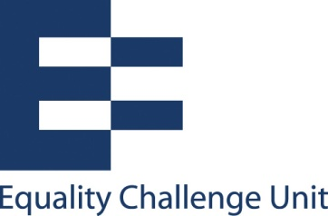

Unconscious bias training: Hand-out 6

Confirmation bias
People have a natural tendency to be selective in the evidence we listen to and the evidence we disregard. We do this through the way we:
- Search for information

- Interpret information

- Remembering/recalling information
We prefer information which confirms what we know and believe and are more likely to overlook information which challenges or contradicts.

Confirmation bias in the way we view people
You meet someone and unconsciously categorise them

The stereotypes and societal norms linked to those categories are linked to that individual

You are more likely to notice and remember their behaviour which is in keeping with the categories into which you have placed them – thereby reinforcing your opinion of them in that category. You are proving yourself to be correct.

You are less likely to notice and remember their behaviour which does not fit within the category

Impact on decision making and behaviour
There is potential for unconscious biases to impact on how we perceive others’ ability and how we remember the work they have undertaken and what they have accomplished. For example:

Staff
- Who we talk about as being particularly good/bad at their job
- Who we give credit/blame to
- Who is encouraged/discouraged to apply for promotion
- Who is trusted with the most high-profile work and work opportunities
- Who receives good/bad appraisals

Students
- How good/bad aspects of a students’ performance are noticed and remembered
- The marks students are awarded depending on how forgivingly mistakes are looked upon or not
- Which students are encouraged to pursue further study

There are various psychological studies on this, for example, Snyder, M., & Swann, W. B. (1978). Hypothesis-testing processes in social interaction. Journal of Personality and Social Psychology, 36 , 1202–1212

