Supporting appraisees through challenging situations
  - Tools to offer the appraisee
Appraisal gives a once in a year opportunity for reflection with protected time. Appraisal does not solve problems, but appraisers can signpost resources and tools for approaching issues in a way that may allow the appraisee to gain some control over seemingly intractable problems.
The first tool we offer as appraisers is Active Listening which lies at the very heart of the appraisal process:
- Give the person your full attention.
- Listen carefully to their words and their body language.
- Ask open-ended questions to encourage them to elaborate to help you understand the issue.
- Reflect back what you’ve heard to show that you understand.
- Be patient and allow them to express themselves.
Below are some additional tools that may be useful.

Creative thinking: brainstorming
Brainstorming, also known as Blue-sky thinking, can help the individual identify what they want to work towards. It involves encouraging them to think creatively without any restrictions and identify what the “ideal” would look like. It is important to encourage lots of ideas to be generated quickly (minimum of 20). Encourage the person to imagine they were in this ideal future:
- How would they feel? What would they be doing?
- How are they interacting with family/colleagues? etc
Having come up with lots of ideas, both realistic and non-realistic, the individual then reviews the list and identifies what is most important and what they could take forward. It is then possible to set a goal for the first step to move towards what they want to work on. This goal could be added to the PDP.
Blue-sky thinking is a technique that is covered in the refresher appraiser workshop, Improving Appraisal Conversations.

Cost Benefit Analysis
If the appraisee is struggling to decide on one course of action compared to another, then weighing up the “cost” and the “benefit” of each action in terms of time, energy, impact on others, impact on wellbeing can bring useful insights. The “cost” can also be assessed in terms of who meets the cost, is it the appraisee, family, department, wider organisation. Does the benefit out-weigh the cost to the appraisee, their department and their organisation, if not, what needs to change, how does this impact their goals. Again, you can map this out with your appraisee as a visual aid. For example, exploring how to change the time of a multi-disciplinary meeting, explore the costs and benefits in terms of self, the department and the organisation, see table below:
Costs | Benefits
- Adjustment to established schedules  - Possible Wednesday diary conflicts  - Need to move recurring appointments  - Less uninterrupted Wednesday mornings  - Energy cost to self of trying to bring in this change | - Higher energy and engagement  - Improved focus and participation  - More time to complete actions  - Decisions influence the rest of the week  - Reduced Friday fatigue  - Stronger team momentum

Force Field Analysis
This technique identifies the forces that act in a particular situation. There are forces working for change and forces operating for stability. When these are in balance there is state of equilibrium, but if one set of forces increases in strength or weakens then there is no longer a balance and change may occur, which may or may not be desired. If the appraisee is wanting to bring about a change, encourage them to identify all the factors that work to hold the current situation in place and then all the factors that would support change. It can help to draw this out as shown here, using the same example:
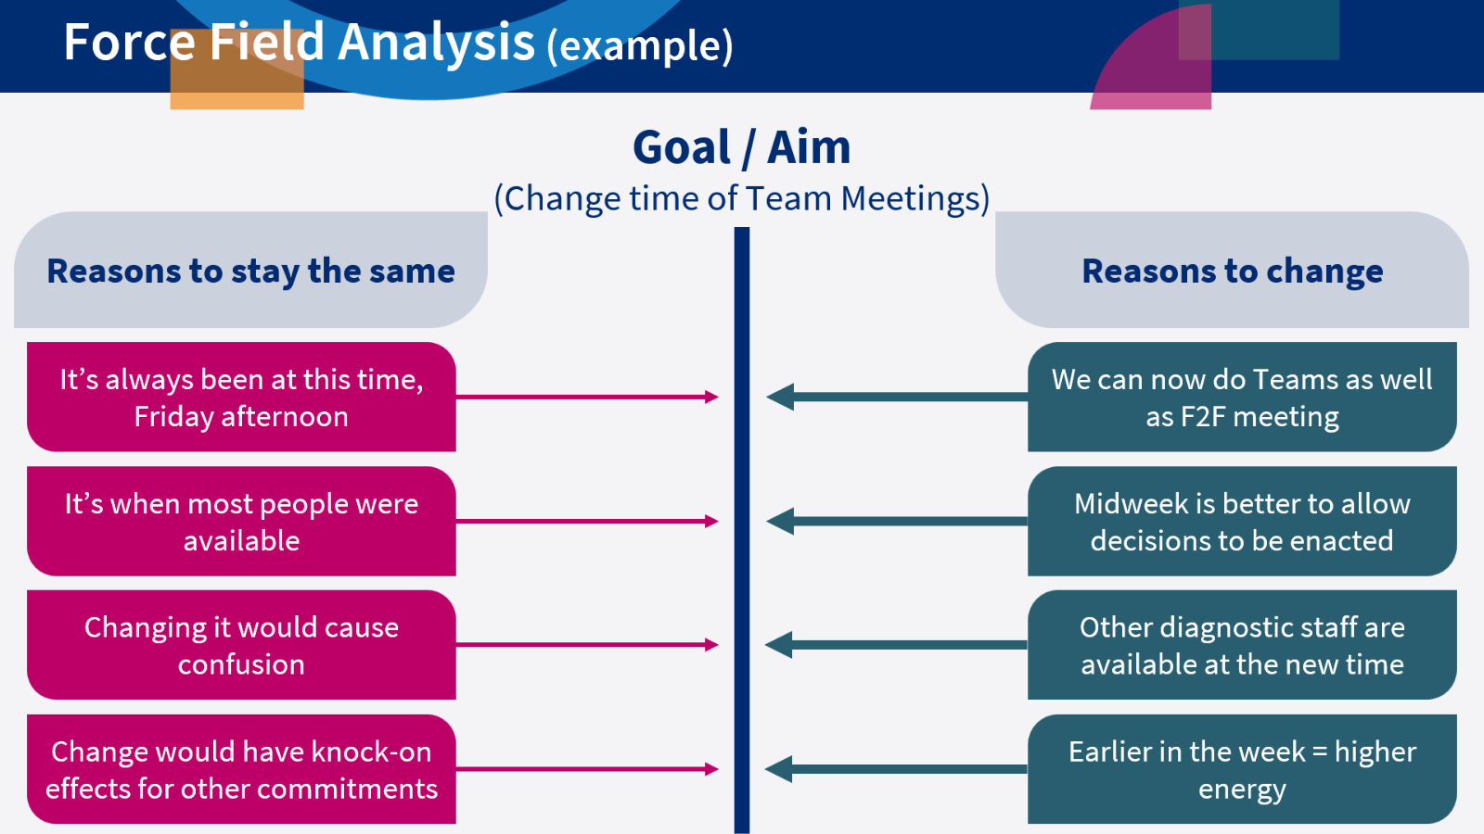
Exploring these “for” and “against” forces may allow the individual to confront blind-spots and gain some new perspectives. Some specific areas to work on could emerge, to strengthen the drivers for change and reduce the inertia. Within the appraisal conversation there may not be time to fully explore this, but it can be helpful to introduce the idea to the appraisee and encourage them to try it out. In this example, having some 1:1 conversation with those who fear change may help.

Wheel of Work / Life
This is valuable in making decisions about work/life balance and career options. It is unlikely that there would be enough time within an appraisal to undertake this exercise, but it can be a valuable tool to offer to someone who is overwhelmed with responsibilities and struggling to identify the way forward. It is an exercise people can do individually and might well be combined with signposting them to other resources such as Mentoring or Occupational Health.
The individual is asked to identify 8 to 10 key areas in their work or it could be widened to their life as a whole. They then rank these in terms of how much they value or how much satisfaction they gain from each area, followed by how much time they currently give to each area. There are templates online to allow this to be developed pictorially. What often emerges is that the most valued aspect of life or of work is the one that receives a low proportion of time.
Visualising this opens the way to change. In our wheel of work example, shown below, the individual has ranked parts of their work from one (least valuable and satisfying) to eight (most valuable and satisfying), shown by the shaded bars. The percentage of time spent on each area is shown by the dots:
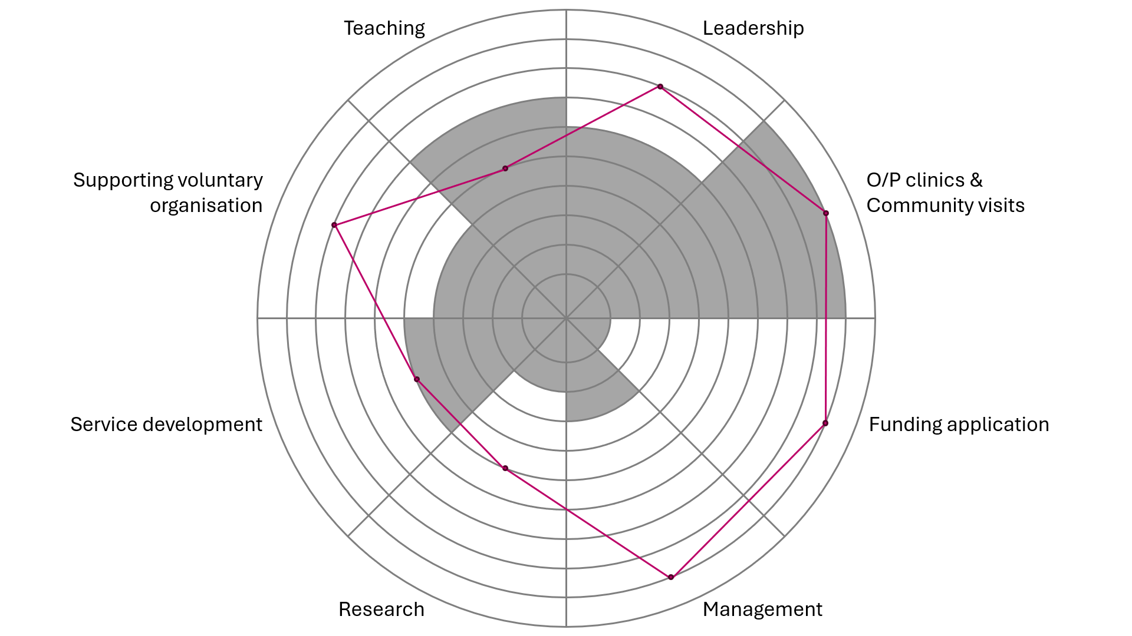
In this example it is evident that teaching, leadership and service development are areas of significant importance for job satisfaction, but there is little time for them compared to the time taken up with seeking funding and management which give low levels of satisfaction. Identifying this could encourage the individual to seek a review of their job plan. They rank teaching very highly but have minimal time so perhaps this is a meaningful development goal to work towards
(See blank versions in appendix in Word and Excel format.)

Resources
All these tools are commonly used in Coaching and Mentoring and there is a wealth of information online about all of them. The value of using an evidence-based tool is that it gives a structure to the exploration. Many of these tools benefit from being drawn or written out. This visualisation can lead to fresh insights and uncover blind spots.
A particularly useful book that summarises these and other resources is Coaching and Mentoring at Work: developing effective practice. Connor M Pokora J 2017.

Appendix
A blank template in the next page can be printed for those wanting to do the wheel of work / life exercise manually. Alternatively, you can download an Excel version from the Medical Appraisal Scotland website:
https://www.appraisal.nes.scot.nhs.uk/media/kfpdhx2s/wheel_of_work_life.xlsx
Wheel of work / life (template)
Add heading to each of the 8 segments, then rank them in order of importance or joy/satisfaction (shade) and time spent (dots) out of 8.
Reflect on significant differences in the ranking (e.g. too much time spent on unimportant areas etc).

